SOFTWARE CONSTRUCTION AND DEVELOPMENT
Week 4 Laboratory Assignment
From a Monolithic Program to Cohesive Python Modules
Field | Details
Student name | Sadia Sohail Chaudhary
Roll number | SU92-BSSEM-F23-182
Date | 4th October 2026

Part A — Code Archaeology
The original code was not changed. Each block below is tagged with the responsibility it performs.
Code | Responsibility | Observation
name = input("Enter student name: ") | INPUT | Reads raw text from the keyboard.
marks = []  for i in range(3):  mark = float(input(f"Enter marks for subject {i + 1}: ")) | INPUT | Collects each mark from the user. The number 3 (subject count) is a hard-coded assumption.
while mark < 0 or mark > 100: | VALIDATION | The rule “marks must be between 0 and 100”.
print("Invalid marks. Enter 0-100.") | DISPLAY (error message) | Presentation of a validation failure, mixed inside the rule itself.
mark = float(input(f"Enter marks for subject {i + 1}: ")) | INPUT (re-prompt) | Duplicate of the first input line (repeated code).
marks.append(mark) | INPUT (data collection) | Stores the accepted mark.
total = sum(marks)  average = total / len(marks) | CALCULATION | Pure arithmetic with no I/O.
if average >= 80: grade = "A"  elif average >= 70: grade = "B"  elif average >= 60: grade = "C"  elif average >= 50: grade = "D"  else: grade = "F" | GRADING / BUSINESS RULE | Institution policy: the thresholds can change independently of arithmetic.
print("\nStudent Result")  print("----------------")  print("Name:", name)  print("Total:", total)  print("Average:", average)  print("Grade:", grade) | DISPLAY | Output format and wording.
main() | COORDINATION | Entry point: runs everything in order.

Key finding: the validation loop is the most tangled part. In four lines it mixes the validation rule, the error message (display) and the re-prompt (input). Changing any one of these means editing the same loop.

Part B — Responsibility Map
Responsibility | What does it do? | Where should it live?
Input | Asks the user for the name and marks and converts text to numbers (float). | main.py (the read_mark() helper and the name prompt). It is application flow, so the coordinator owns it.
Validation | Decides whether a mark is acceptable (0 to 100 inclusive). It only answers True or False. | validation.py, via validate_mark(mark).
Calculation | Computes the total and the average of the marks. | calculations.py, via calculate_total() and calculate_average().
Grading rule | Converts an average into a letter grade (A to F) using policy thresholds. | calculations.py, via calculate_grade(). It is a business rule with no I/O.
Display | Formats and prints the final result. | display.py, via display_result(name, total, average, grade).

Part C — Design the Modules
student_marks/
├── main.py
├── validation.py
├── calculations.py
└── display.py
I kept the suggested structure. The only additions are a small read_mark() helper in main.py and named constants (MIN_MARK, MAX_MARK, INVALID_MESSAGE) in validation.py. These remove the duplicated input line and the magic numbers without adding new modules.
Why does each module exist?
- validation.py holds the rules about what counts as a valid mark, so the rule changes in one place.
- calculations.py holds the pure logic (total, average, grade). It has no input or output, so it is reusable and easy to test.
- display.py holds everything about how results look, so the look can change without touching logic.
- main.py holds the application flow: it connects the other modules in the right order.
Which functions belong in calculations.py?
calculate_total(marks), calculate_average(marks) and calculate_grade(average). The grade is derived purely from numbers, so it is business logic rather than presentation. If grading policy grew more complex, calculate_grade could be split into its own grading.py, but for this size one module is enough.
Should display.py calculate the grade? Why?
No. Display should only show values it is given. If display.py calculated the grade, the grading rule would be hidden in the presentation code. A GUI or web page would then have to copy the rule, and a grading policy change would require editing display code. Grading is a business rule, so it belongs in calculations.py.
What should main.py coordinate?
The order of the workflow: ask for the name, read each mark until it is valid (using validation), call the calculation functions to get total, average and grade, and pass the results to display. main.py contains no arithmetic, no grade thresholds and no formatting.
Which implementation details should other modules not need to know?
- main.py does not need to know the valid range (0 to 100) or the grade thresholds.
- calculations.py does not need to know how or where results are shown, or where marks come from.
- display.py does not need to know how total, average or grade were computed.
- validation.py does not need to know about prompts, grades or output.

Part D — Implementation
Project structure and complete source code of each module:
validation.py
"""validation.py - Rules for deciding whether a mark is acceptable."""

MIN_MARK = 0
MAX_MARK = 100
INVALID_MESSAGE = "Invalid marks. Enter 0-100."

def validate_mark(mark):
"""Return True if mark is within the allowed range (0-100), else False."""
return MIN_MARK <= mark <= MAX_MARK
calculations.py
"""calculations.py - Pure business logic: totals, averages and grading rule.

No input() or print() calls live here, so the logic can be tested and
reused with any user interface (console, GUI, web).
"""

def calculate_total(marks):
"""Return the sum of all marks."""
return sum(marks)

def calculate_average(marks):
"""Return the average of the marks."""
return calculate_total(marks) / len(marks)

def calculate_grade(average):
"""Return the letter grade for an average mark."""
if average >= 80:
return "A"
elif average >= 70:
return "B"
elif average >= 60:
return "C"
elif average >= 50:
return "D"
else:
return "F"
display.py
"""display.py - Presentation of the result. Knows nothing about how values are computed."""

def display_result(name, total, average, grade):
"""Print the formatted student result."""
print("\nStudent Result")
print("----------------")
print("Name:", name)
print("Total:", total)
print("Average:", average)
print("Grade:", grade)
main.py
"""main.py - Coordinates the application: input -> validate -> calculate -> display."""

from validation import validate_mark, INVALID_MESSAGE
from calculations import calculate_total, calculate_average, calculate_grade
from display import display_result

NUMBER_OF_SUBJECTS = 3

def read_mark(subject_number):
"""Prompt for one mark and keep asking until it is valid."""
mark = float(input(f"Enter marks for subject {subject_number}: "))

while not validate_mark(mark):
print(INVALID_MESSAGE)
mark = float(input(f"Enter marks for subject {subject_number}: "))

return mark

def main():
name = input("Enter student name: ")
marks = [read_mark(i + 1) for i in range(NUMBER_OF_SUBJECTS)]

total = calculate_total(marks)
average = calculate_average(marks)
grade = calculate_grade(average)

display_result(name, total, average, grade)

if __name__ == "__main__":
main()

How to run: open a terminal in the student_marks folder and run python main.py.
Behaviour check: I ran the original monolithic program and the new modular program on the same inputs (all cases in Part G). The output was identical in every case, so the refactoring did not change the required behaviour.

Part E — Dependency Mapping
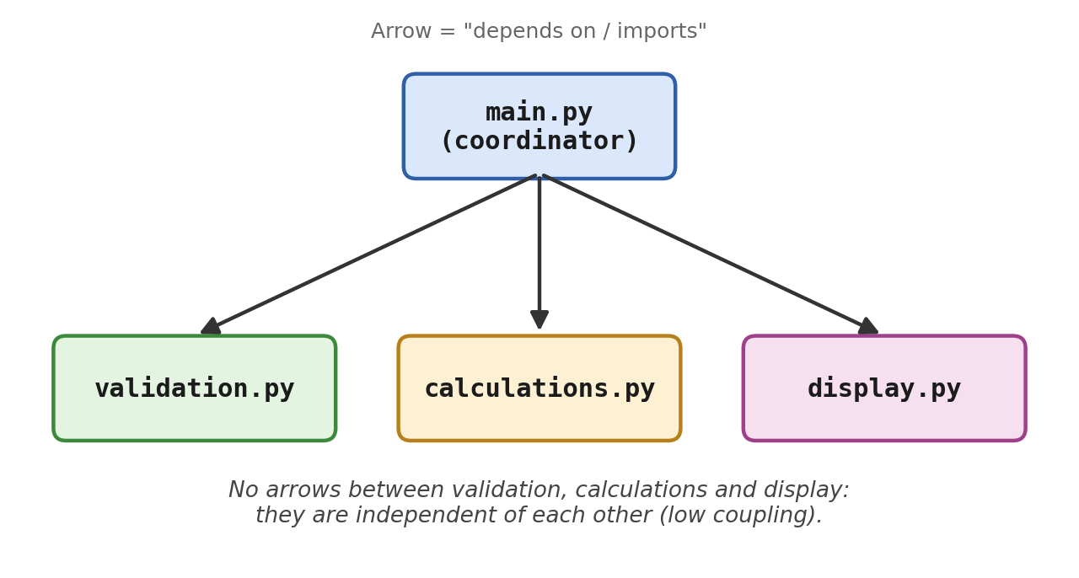
Which modules does main.py depend on?
validation.py (validate_mark, INVALID_MESSAGE), calculations.py (calculate_total, calculate_average, calculate_grade) and display.py (display_result). The other three modules depend on nothing but Python itself.
Does display.py need to know how the grade is calculated?
No. It receives the finished grade as a parameter and just prints it. It does not import calculations.py.
Does calculations.py need to know how results are printed?
No. It only returns values and has no print() or input() calls, and it does not import display.py.
What would happen if display.py were replaced by a GUI?
Only display.py (or the single import line in main.py) would change. validation.py and calculations.py would not be touched, because they have no knowledge of the console. This is the benefit of separating concerns.
Which dependencies are necessary and which would be unnecessary?
- Necessary: main.py → validation, calculations and display. The coordinator must use the others.
- Unnecessary (avoided): display → calculations (display recalculating the grade), calculations → display (calculations printing), and validation → display (validation printing its own error message). Any of these would create hidden links and make modules harder to change or replace.

Part F — Change Request Test
Change request | Module to change | Explanation
Change 1: grading becomes A ≥ 85, B ≥ 75, C ≥ 65, D ≥ 55 | calculations.py | Only the thresholds inside calculate_grade() change. main.py and display.py are untouched.
Change 2: the result format changes | display.py | Only display_result() changes (labels, layout, decimals). The calculation logic is not affected.
Change 3: the validation message changes | validation.py | Edit the INVALID_MESSAGE constant. main.py just prints whatever message it is given.
Change 4: results later shown through a GUI | display.py (replaceable) | The display layer (and the input prompts in main.py) can be swapped for a GUI. validation.py and calculations.py stay unchanged because they have no console code.

Change 1 example (calculations.py only):
def calculate_grade(average):
if average >= 85:
return "A"
elif average >= 75:
return "B"
elif average >= 65:
return "C"
elif average >= 55:
return "D"
else:
return "F"

Part G — Verify
Every case below was run on both the original and the modular program, and the outputs were identical. Only the key results are shown here.

1. Normal marks
Marks | Total | Average | Grade | Status
75, 82, 68 | 225.0 | 75.0 | B | Pass: matches expectation

2. Boundary marks
To test each grade boundary exactly, all three marks were set to the same value so the average equals the boundary.
Marks | Total | Average | Grade | Status
50, 50, 50 | 150.0 | 50.0 | D | Pass: 50 is the lowest D
60, 60, 60 | 180.0 | 60.0 | C | Pass: 60 is the lowest C
70, 70, 70 | 210.0 | 70.0 | B | Pass: 70 is the lowest B
80, 80, 80 | 240.0 | 80.0 | A | Pass: 80 is the lowest A

Just below the boundaries (tested directly with calculate_grade): 49.99 → F, 59.99 → D, 69.99 → C, 79.99 → B. The limits of the valid range were also tested: validate_mark(0) and validate_mark(100) return True.

3. Invalid marks (−5 and 105)
Input sequence: name “Invalid”, then −5 (re-prompted), 80, 105 (re-prompted), 90, 70.
Enter student name: Invalid
Enter marks for subject 1: -5
Invalid marks. Enter 0-100.
Enter marks for subject 1: 80
Enter marks for subject 2: 105
Invalid marks. Enter 0-100.
Enter marks for subject 2: 90
Enter marks for subject 3: 70

Student Result
----------------
Name: Invalid
Total: 240.0
Average: 80.0
Grade: A
The invalid marks −5 and 105 were rejected with the message “Invalid marks. Enter 0-100.” and were not included in the total.

4. A second student with a different result
Name | Marks | Total | Average | Grade | Status
Sara | 92, 88, 79 | 259.0 | 86.333… | A | Pass
Bilal | 40, 35, 50 | 125.0 | 41.666… | F | Pass

Student Result
----------------
Name: Sara
Total: 259.0
Average: 86.33333333333333
Grade: A

Reflection
1. What is the difference between separating code into functions and separating code into modules?
Functions break one file into smaller steps, but they are still in the same file, share the same namespace and can easily reach each other. A module is a larger unit with its own file and its own responsibility. It exposes a small public interface (such as validate_mark) and hides everything else. Functions organise the code, while modules organise the design: they set boundaries, can be changed or tested separately, and show clearly who depends on whom.
2. Which module has the strongest cohesion? Explain.
calculations.py (and display.py is a close second). Every function in calculations.py works with numbers to produce a result: total, average and grade. None of them does input or output. Its functions are closely related and use no outside resources, so the module has a single clear purpose and is easy to test.
3. Give one example of coupling in your program.
main.py is coupled to validation.py because it imports validate_mark and INVALID_MESSAGE. If validate_mark were renamed or its return value changed (for example, to raise an exception instead), main.py would also have to change. This coupling is intentional and low, because main.py depends only on a small function interface and a message constant, not on how the rule works inside.
4. How does modularity help when requirements change?
A change stays in the module that owns that responsibility. In Part F, new grade thresholds meant editing only calculate_grade(), a new output format meant editing only display_result(), and a new validation message meant editing one constant. A GUI would replace the display layer without any change to the calculation logic. Because the changes are isolated, there is less risk of breaking unrelated code, and testing is limited to the module that changed.
5. Did you create a module that is too broad or too small? Explain.
No module is too broad. Each has one reason to change. validation.py is the smallest (one function and two constants), which might look too small, but it separates a rule that is very likely to change (for example, different mark limits per subject) and gives validation a clear home as the project grows. The one module that could become too broad is calculations.py, because it contains both arithmetic and the grading policy. If grading became complex (e.g. different scales or GPA calculations), I would split calculate_grade into a separate grading.py.

Semester Project Connection
Note: replace the example below with your own semester project. The example uses a hypothetical “Library Management System” to show the expected reasoning.
Responsibility | Possible module | Main dependencies
User interface / menus | ui.py (or main.py) | Depends on services; knows nothing about storage details.
Business rules (borrow limits, fines) | rules.py / services.py | Depends on models only.
Data model (Book, Member, Loan) | models.py | Depends on nothing.
Data storage (files or database) | storage.py | Depends on models; services use it through a small interface.
Input validation | validation.py | Depends on nothing.

Dependencies flow in one direction: UI → services/rules → models and storage. The business rules never print or read files directly, so I can change the UI, or switch from files to a database, without rewriting the rules. This is the same reasoning as in the Student Marks project: clear responsibilities, cohesive modules and manageable dependencies.

